James a

**R.E.**

We will be looking in detail at the Christian Creation story this term. We will sequence this story, write our own versions and illustrate them with our own images and collages. We will reflect on the wonder of creation.

**History**

St. George’s Hall

We will look in detail at the history of St. George’s Hall including how, why and when it was built. We will visit the Concert Hall, the Grand Hall, the Crown Court and the Prison Cells to get a feel for what it felt like to be in this building in the 19th century.

**Homework will be given out on Friday.**

**PE**

**Year 2: PE day is Thursday**

**Music**

We will be learning about Beethoven and listening to some of his most famous pieces of music.

**PSHE/ Jigsaw**

We will look in detail at ‘being me in my world’. We will discuss the children’s hopes, fear and responsibilities. The children will take part in a range of activities and whole class discussions.

**Science**

We will be finding out what materials are and why they are used for certain objects. We will also be investigating the properties of different materials and choose a material most suitable to rebuild the pig’s house that have been destroyed.

**Art**

We will be looking closely at the work of Ben Johnson. When we visit the Museum of Liverpool we will take part in a workshop about Liverpool’s iconic buildings and we will use this to help us create our own painted skylines using watercolour paints.

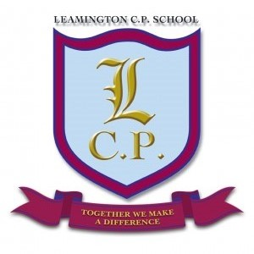

**Year 2 Home/School Sheet**

**Autumn 1 2018**

**Maths**

We will be focussing on basic skills in Maths. We will count in steps of 2, 5, 10 and 3 and place value using dienes, numicon, place value cards and money. We will compare and order them using our place value knowledge.

We will also begin adding and subtracting numbers, using apparatus such as number lines, hundred squares and numicon. We will move on to solve problems using the skills we have learnt.

**English**

We will begin our school year by immersing ourselves in the world of traditional tales. We will be reading lots of versions of the most popular tales and we will be looking carefully at the characters and themes found in these books. We will be playing the part of police investigators and making sure we get the whole story to find out if the baddies are really as bad as the stories say they are! We will also be writing instructions and recipes for our favourite characters’ treats.