James a

**Geography**

This half term children will be exploring their local area. They will be visiting their local area, using maps to explore then going on to create our own. Finally we will discuss how we can develop our local area and our school by suggesting improvements.

**English**

Our English topic will be focused around the book ‘The Elves and the Shoemaker’. We will begin our half term by looking at predictions, generating vocabulary and improving our sentences. The children will also be exploring a selection of stories with traditional tales. We will then be creating our own senses poetry pieces.

**PE**

**Year 1:** PE day is Tuesday

**Music**

We will be exploring the topic ‘Little Angels get her Wings’ in music and will be completing a variety of practical activities.

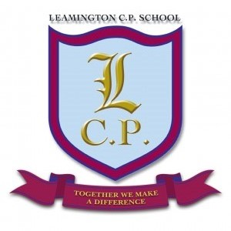

**Year 1 Home/School Sheet**

**DT**

We will be creating a ‘Moving picture Christmas card’. Children will be experimenting with a range of materials then designing, evaluating and creating their own moving picture Christmas card.

**Science**

During science this half term we will be looking at everyday materials. Children will look at a range of materials and be able to name them whilst identifying their properties. Children will be able to find the most appropriate material for the shoemaker to use when making his shoes.

**R.E/PSHE**

During R.E. this term we will be exploring Hinduism and Christmas.

Throughout PHSE we will be following the scheme Jigsaw.

**Maths**

During this half term we will be concentrating on number. We will be focusing on our number bond knowledge through practical activities and then moving onto problem solving. We will incorporate shape, time, weight and money across our number bond tasks.

**Computing**

During computing this half term we will be developing our computer skills using Pic Collage to create a poster for the ‘Shoe workshop’.