James a

Remember a water bottle and a healthy snack for playtime.

**Science**

This term we will be learning about electricity. We will be answering the question: How could we cope without electricity? We will start the term by exploring electricity and how it works. Then we will research famous electrical inventors before investigating how to make a simple circuit to light a bulb and finally take on the role of an electrician to help problem solve and fix some broken circuits.

**Computing:**

Our next computing topic is called ‘Collecting, Exploring and Recording Data.’ This half term we will focus on using computers to help capture and store information. By the end of the topic we will be using these new skills to present information through charts and graphs.

**Design and technology**

This term we will be linking our DT and science topics and focus on making a lamp. First the children will identify the different features of a lamp and establish a the most efficient design. The children will then use their knowledge of circuits from our science lessons to help them design and make their own torch before finally evaluating their product.

**R.E**

This term we are focusing on ‘Mary’s Journey’. The children will be focusing on life as a journey and how milestones mark key points in life. We will then explore how Mary’s journey started using drama and identifying the milestones at each stage of her Journey.

**Music**This year we will belearning to play guitars. We will have weekly lessons and be working towards an assembly for parents.

**Year 4   
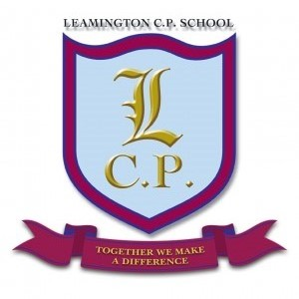Home/School Sheet**

**Autumn 2**

**PE**This half term we will be completing a yoga and peer massage course.

Please ensure your child brings a full P.E. kit and water bottle to school.

**PSHE**

This year we have introduced new and exciting PSHE lessons. We will be attending lots of mindfulness assemblies throughout the week and having a special mindfulness hour every Friday 2-3pm. The topic this half term is ‘Celebrating differences’.

**English**   
This term we will move on to complete our work on imaginary worlds. Children will look at emotions within a setting as well as use amazing adjectives and adverbs to describe settings and then creating their own imaginary world story.

In November, we will take part in anti-bullying activities and complete some drama based lessons after looking at Lowry’s painting ‘The Fight.’

**Geography**

Our geography topic will aim to answer the question: ‘Where would you choose to build a city?’ We will start this term by exploring both past and modern settlements and how they got their names. The children will then use their mapping skills to compare land use and investigate transport links before finally designing their own settlement.

**Maths**This term the children will be working on ‘Multiplication and Division’. Children will focus on recalling multiplication and division facts, multiply and divide mentally and multiply two numbers together using the formal written layout.   
  
They will continue to learn their times tables with this year’s focus on: 6, 7, 8 and 9 times table, and the corresponding division facts. Children will be tested once a week during PPA on the times tables they are working on.