James a

**Why not visit the Museum of Liverpool for an amazing workshop on the Stone Age?**

**R.E**

**Lights:**

Throughout our RE topic this half term, we will be focusing on light. Children will explore the use of light in the story of Christmas and using them with Christingles. Children will use light as focus of positive through meditation and reflection.

**Computing:**

**Produce, Edit & Publish media**

Throughout our Computing topic, children will create short narrated still-image movie. Through this topic children will prepare short scripts for their narration to improve and add suitable transitions and effects. We will then move on to recording with clear expression and using effects tools to enhance the images on the video.

**Maths**This term the children will continue working on number continuing with our different operations including subtraction, multiplication, division and fractions. Children will learn to use and apply multiplication and division methods, which will include both mental and written strategies. We will then progress to fractions before Christmas in which we will discuss reading and writing fractions, finding fractions of a shape and number as well as comparing and ordering fractions. As always, times tables remains an important area of learning. The children will concentrate on the application of the times tables across all areas of maths. Children will also be tested every Thursday on the specific times tables they are working on.

**Design Technology**

This term we will be looking at healthy food and the children will be designing and making their own healthy sandwiches. The skills for this will include cutting, slicing, grating and spreading. We will also be investigating the seasonality of foods.

**Science**

Our topic this term is ‘Animals including humans’. We will be looking at the structure of the human body including the skeleton and the muscular system. We will discuss what is in a healthy diet and why this is important to the development and maintenance of our health.

**PE**

**Year 3 will have PE every Wednesday**

**Music  
Samba**This term we will be focusing on learning our new rhythm Zebra Shuffle

**History**

**Who first lived in Britain?**

This term the children will explore ‘Who first lived in Britain?’ We will be researching the span of history from the Stone Age, through to the Bronze Age and up to the Iron Age. The children will be excited about this new topic in the curriculum and find out about how once our country was attached to Europe by land. We will look at the types of civilisations that existed, how they lived, what their houses were like and what weapons they used.

**What you can do at home:**

Go to the library and get out books on the Stone, Bronze or Iron Age. If you’re in Liverpool city centre visit the museums and become history detectives. If possible also use the internet to explore who first lived in Britain.

**Year 3 Home/School Sheet**

**Autumn 2  
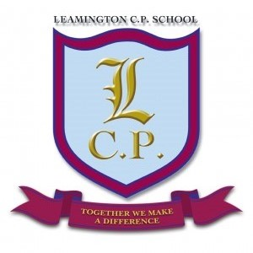**

**English**Our units of work for this half term will cover instructions and descriptive writing. The language features of adjectives verbs and adverbs will be reinforced from last terms poetry unit. We will also be reading, writing and acting out different types of instructions. Our descriptive writing will also be based on our narrative from the Stone Age which links to our history topic. As always we will be reinforcing spellings, sentence work and handwriting throughout our English lessons. Children will receive weekly spellings that meet age expectations.