James a

**R.E.**

We will be looking in detail at the Christmas story. We will start by imagining what it was like for the shepherds on the hill when they received their good news. We will also think about the wise men and how they would have felt.

**Geography**

Liverpool

We will look carefully at the geography of Liverpool, where it sits in the country and the main human and physical features found here. We will use postcodes to locate places of interest in Liverpool and design routes to get from one place to another.

**Homework will be given out on Friday.**

**PE**

**Year 2: PE day is Thursday**

**Music**

We will be learning about Debussy and listening to some of his most famous pieces of music.

**PSHE/ Jigsaw**

We will look in detail at celebrating differences. We will discuss why it is god to be different and friendships. The children will take part in a range of activities and whole class discussions.

**Science**

What do plants need to grow?

We will begin our topic by planting vegetables and monitoring them over the term. The children will research what a plant needs to grow and carry out an investigation to find the best area in school to grow plants.

**Art**

We will be looking closely at the work of Tula Moon. We will start with an artist study of Steph Dekker, the artist responsible for Tula Moon images. We will then plan, design and make our own collages of iconic Liverpool buildings.

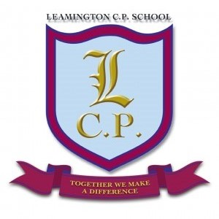

**Year 2 Home/School Sheet**

**Autumn 2 2018**

**Maths**

We will look at addition and subtraction methods such as using a number line, blank number line and expanded columnar. The children will use these methods to solve a variety of problems and investigate number.

The children will also look at multiplication and division. They will use a range of practical and written strategies to solve problems.

**English**

We will begin the term with our new Narrative Immersion text. The children will meet Red, a little boy who is struggling to concentrate at school. They will help him find ways to know when it is OK to be loud and when he should be quieter. We will be thinking about wishes and writing stories about how we can make our wishes come true. We will also be writing facts about Liverpool and using these to create information texts for the Tourist Information Centre.