James a

**English**

Our English topic will be focused around the book Where the Wild Things Are’ as children will be exploring fantasy world stories. The children will begin by exploring the characters in the story through drama activities alongside their basic skills and sentence work. The children will also be exploring a selection of stories with familiar settings, before creating their own story.

**Geography**

This half term children will be exploring Mapping Skills. We will name the five oceans and seven continents. They will explore the Galapagos Islands and compare it to their local area and will also develop their understanding of directional vocabulary.

**PE**

**Year 1: PE day is Tuesday**

**Music**

We will be exploring in the groove and will be completing a variety of practical activities.

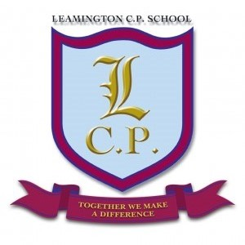

**Year 1 Home/School Sheet**

**Art**

We will be looking at 3D modelling. We will begin by exploring work and techniques by the artist James DeRosso. Children will then design and make their own Wild Thing out of clay.

**Science**

During science this half term we will be looking at plants and trees. We will explore name and identify a variety of common plants and trees. We look at the parts a plant and the difference between evergreen and deciduous trees.

**R.E/PSHE**

During R.E. we will be exploring Judaism.

Throughout PHSE we will be following the scheme Jigsaw.

**Maths**

During this half term we will be concentrating on number. We will first work on counting forwards and backwards from any given number and also look at place value. We will also begin to look our 2, 5 and 10 times tables. We will then apply our understanding in a real life context and develop our problem solving skills.

**Computing**

During computing this half term we will be exploring coding, digital communications and the web. We will help Max to get to the island.