James a

**R.E.**

We will be looking in detail at the lie of Mother Teresa. We will be thinking about the positive qualities of this amazing lady and thinking how we can be more like her in our everyday lives.

**History**

Who were the Beatles?

We will look in detail at the life of the Beatles. We will find out who they were, how they became famous and listen to some of their most popular songs. We will also be visiting the Beatles Story Museum at the end of the half term.

**Homework will be given out on Friday.**

**PE**

**Year 2: PE day is Wednesday**

**Music**

We will be learning lots of songs by the Beatles including ‘Octopus’s Garden’ and ‘Yellow Submarine’.

**PSHE/ Jigsaw**

We will be thinking about a variety of things we have achieved from winning competitions to riding our bike for the first time. The children will then set themselves a goal they would like to achieve by the end of the year.

**Science**

Food chains and habitats

We will be looking at how living things survive. We will focus on their habitats and food chains. We will explore different habitats and identify from the environment which animals would live in each. We will look at examples of different food chains and carry out research to create our own food chains.

**Design Technology**

We will be researching, designing and making our own hand puppets. We will turn these into puppets of the Beatles and will use them to tell the story of the Beatles rise to fame.

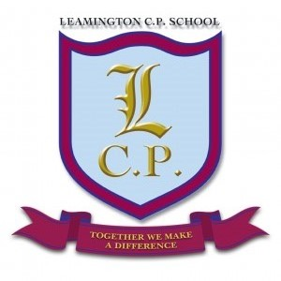

**Year 2 Home/School Sheet**

**Spring 2.1 2019**

**Maths**

The children will also look at multiplication and division. They will use a range of practical and written strategies to solve problems.

We will begin by looking at fractions of 2D shapes and numbers. We will focus on quarters, halves and thirds.

**English**

We will begin our half term by looking at the lyrics of a famous song by The Beatles. We will use this as the base to conduct some research into creatures that live under the sea. This information will be turned into a non-chronological report about sea creatures. We will then move on to writing riddles about sea creatures, using the information we have already learnt. We will finish the half term by writing our own under the sea poetry.