James a

**Geography**

**Why are Rainforests important?**

We will start our new learning challenge this half term, where we will look closely at different rainforests. We will look at the features of the rainforests. We will then look at the impact that rainforests have on the world and what would happen if they were destroyed. This will also lead into looking at then water cycle.

**Computing:**

We will be using computing to produce, publish and edit media through a documentary style film.

**PE**

PE lessons will be on a Monday afternoon. Children must remember to bring PE kits.

**Maths**

We will begin this half term by looking at fractions – comparing and ordering, finding equivalents and identifying mixed number and improper fractions. We will then move onto decimals and percentages and solve problems to demonstrate our new knowledge. As well as this we will continue to work on our basic skills and keep practicing our multiplication and division facts.

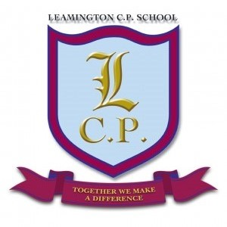

**Year 5 Home/School Sheet**

**R.E/PSHE**

We will be exploring The Bible and why it is a bestselling book. We will explore the different sections of The Bible and why it is important to Christians.

**English**

In English, this half term we will begin our term with our new book; ‘The River Sea’. We will follow Maia on her journey to the Amazon rainforest. We will produce a non-chronological report about the rainforest. We will then explore the effect of deforestation and create a newspaper report. We will then look at figurative language features and create a rainforest inspired poem. Finally, we will finish by writing our own story from another culture.

**Science**

We will be exploring our new topic ‘Do all plants and animals start life as an egg?’ We will begin our topic by studying the work of David Attenborough. We will be exploring and comparing the different plants and animals life cycles. We will observe the life cycle of a butterfly in class.

**Music**

Guitars will take place on Monday - We will begin by improvising and writing and playing our own songs.

**Art**

This half term we will be studying Henri Rousseau and his rainforest artwork. We will be creating our own rainforest style art using batik and printing.

**Remember a healthy snack for playtime.**