James a

Remember to bring a healthy snack and a bottle of water for playtime

**History**

This term the children will be exploring what happened during the Tudor reign. The children will look at a variety of sources and use artefacts, books and Ipads to research Tudors. Then we will create a news bulletin on the Battle of Bosworth before exploring the life of Henry VIII and his six wives. Finally we will complete this topic by experiencing a day in the life of Tudor child. The children will be invited to wear Tudor clothes and have the opportunity to learn a Tudor dance, make a model of a Tudor house and bake some Tudor food.

**Maths**  
We will begin this half term by exploring various units of measure, particularly converting between measures before moving onto calculating perimeter and area of rectilinear shapes.

We will then move onto exploring money and finally reading, writing and converting between analogue and digital 12 and 24 hour clocks. We will use this knowledge to help us solve problems involving time including days of the week and moths of the year.

**English**

We will begin this half term by reviewing a variety of poetry including looking at Acrostic poems, Rhyming poems, Calligrams and Limericks. The children will explore a new and exciting story which will help us discuss the setting, characters, problems and resolutions. Through the term the children will find clues in story boxes and jump into story world before building up to writing their own poem about the story they have experienced and finally write their own story inspired by our topic.

**Art**

Our new topic is based on textiles. We will be looking at a range of tapestries and begin by depicting the Battle of Bosworth through sketch. Then we will use an experiment with a range of different sewing techniques. Before designing and making our own Tudor rose badge.

**Science**  
Our Science topic will aim to answer the question: ‘How is sound enjoyed by so many?’ We will be focusing on how sound travels; where sound goes when it’s been made; how our ears work and the pitch and volume of sound. The children will then be researching who invented the first telephone and creating their own musical instrument to use.

**Computing:**

Our next computing topic is called ‘Collecting, exploring and recording data.’  
We will be collecting information through our healthy eating topic in PSHE, before creating a database of results and finally make a chart from the table of data.

**PSHE**

This year we have introduced new and exciting PSHE lessons. We will be attending lots of mindfulness assemblies throughout the week and having a special mindfulness hour every Friday 2-3pm. The topic this half term is ‘Healthy Me’

**PE**This half term we will be focusing on learning how to play netball

Please ensure your child brings a full P.E. kit and water bottle to school.

**Year 4   
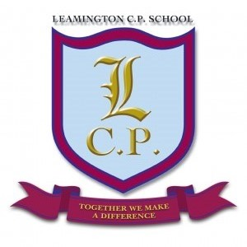Home/School Sheet**

**Spring 2**

**Music**This year we will belearning to play guitars. We will have weekly lessons and be working towards an assembly for parents.

**R.E**

This term we are focusing on ‘Easter’. The children will be focusing the story of Easter. We will begin by retelling and sequencing the story before writing a diary entry exploring how Jesus felt throughout the key events in the story of Easter.