James a

**PE**

PE lessons will be on a Thursday afternoon. Children must remember to bring PE kits.

**Computing:**

This half term we will be exploring digital communications and the web. We will gradually build our own website for Sutton Hoo.

**Maths**

We will begin this half term by completing our fractions, decimals and percentages topic. We will then look at ‘Measure’. We will be learning how to convert between units of measure for length, weight and capacity. We will also be exploring and understanding imperial measures. We will then move onto measuring and calculating the area and perimeter of rectilinear shapes. We will also be solving Anglo-Saxon mathematical problems involving wergild.

**History**

**Were the Anglo-Saxons really smashing?**

* How they influenced our lives today
* Where they invaded from
* Settlements
* Law and order
* We will be looking at Alfred and why he was so great.

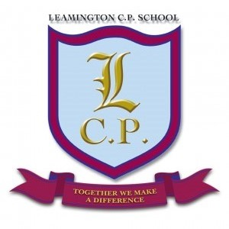

**Year 5 Home/School Sheet**

**R.E**

We will be exploring why the cross is important to Christians. We will look at the Easter story and explore what the cross represents.

**English**

We will begin our half term by exploring different legends linked to King Arthur. We will explore features of a legend story and meet some of the characters from famous legends. We will write an alternative version of sword and the stone. We will create our own legend comic strip. Children will then gather around the round table with King Arthur and share legend stories. Finally, the children will write their own legend story based on what they have learnt this half term.

**Science**

We will be continuing by exploring our topic ‘Do all plants and animals start life as an egg?’ We will be exploring and comparing the different plants and animals’ life cycles. We will then observe the life cycle of a butterfly in class.

**Music**

Guitars will take place on Monday - We will be learning new chords and melodies.

**Art**

This half term we will be studying the work of Michael Carroll. We will be designing and printing our own Anglo-Saxon inspired shields using celtic designs

**Remember a healthy snack for playtime.**