James a

**History**

This half term children will be exploring old and new toys through the theme of Elliot’s toy box in the attic. We will discuss how toys have changed over time, focusing on how they are made what they are made from and the impact technology has had on toys.

**English**

Our English topic will be focused around the book ‘The Story Machine’ as children will be exploring story’s with familiar settings. We will begin our half term by looking at labels, lists and captions. The children will also be exploring a selection of stories with familiar settings. They will be looking at the different characters and settings, before creating their own story.

**PE**

**Year 1: PE day this half term is Wednesday**

**Music**

We will be exploring the topic Hey You in music and will be completing a variety of practical activities.

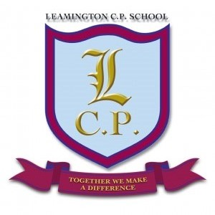

**Year 1 Home/School Sheet**

**DT**

We will be looking at Healthy Eating and will design, make and evaluate a fruit kebab. Children will explore and taste a variety of fruits. They will also look at health and safety when working with food and equipment.

**Science**

During science this half term we will be looking at the human body and our five senses. They will explore body parts, identify their names and discuss what we use them for. They will also investigate their five senses and explore how they help us each day.

**R.E/PSHE**

During R.E. we will be exploring prayers.

Throughout PHSE we will be following the scheme Jigsaw.

**Maths**

During this half term we will be concentrating on number. We will be focusing on the children being able to recognise and write numbers 1-20. Counting objects and finding 1 more and less will also play a big part in the Maths lessons this half term. We will also begin to look at our numbers bonds to 5 and 6 through lots of activities and problems.

We

**Computing**

During computing this half term we will be developing our computer skills with the end goal of creating a picture of Elliot’s attic.