**English**

Our first book we will be studying is ‘The Egyptian Cinderella’. We will be exploring different cultures and traditions. We will be making predictions and eventually writing our own Egyptian fairytale narrative.

**History**

How can we rediscover the wonders of Ancient Egypt?

This half term we will be exploring the discovery of Tutankhamen and the use and history of hieroglyphics. We will also be exploring different Pharaohs and why they were appreciated in Egypt.

**Maths**

This half term in Maths we will be starting with our ‘Number’ topic. We will be looking at place value and ordering and comparing numbers. We will also be exploring negative numbers in real life context and Roman Numerals.

James a

**R.E/PSHE**

We will be exploring our new topic ‘Signs and Symbols’. We will be exploring well-known signs and religious symbols and the meaning behind these.

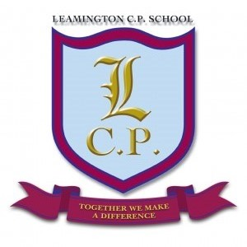

**Year 5 Home/School Sheet**

**Computing:**

We will be using ICT to solve real world technology problems. We will then use computer aided design to create our own 3D pyramids.

**Science**

We will be starting our topic ‘Can you feel the force?’ We will begin our topic with a trip to Walton Hall Park to explore forces around us. We will then carry out investigations to test air resistance, water resistance and friction.

**Design Technology**

This half term we will be studying ‘Food’. We will begin by researching popular Egyptian foods, we will then plan and make our own Egyptian style cuisine.

**Music**

Guitars - We will begin by improvising, writing and playing our own songs.

**PE**

PE lessons will be on a Thursday afternoon. Children must remember to bring full PE kits and appropriate footwear.

**Remember a healthy snack for playtime.**