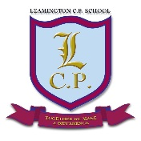
Leamington Community Primary School
Together we make a Difference

Governors Sub Committee Membership 2019/20

Staff and Finance
- Paul Vine, Pat Monaghan, Kathy Kerwin, and Dawn Mercer.

Curriculum
- Rachel Mellor, Jennifer Evans, Rachel Atherton, John Prince, Carly Gibbons and David Smith

Building
- Paul Vine, Pat Monaghan, Alma Shaw, David Smith and Rachel Atherton

Children’s Centre
- Paul Vine/Marie Egerton Jones (Chair of Board) Alma Shaw, Jennifer Evans, Rachel Mellor.

Governors Responsibilities

Curriculum | Safeguarding | Inclusion | Attendance | Health and Safety | Wellbeing
John Prince and Carly Gibbons | Dawn Mercer and David Smith | Alma Shaw | Rachel Atherton | Pat Monaghan | Kathy Kerwin  * Marie Egerton Jones

