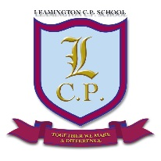
Leamington Community Primary School
Curriculum Overview
Humanities (History and Geography)
 | Year 1 | Year 2 | Year 3 | Year 4 | Year 5 | Year 6
Autumn 1 | Changes in my life time:  Toys from the past | How has St. George’s Hall changed? | What makes the Earth angry? | Romans | Egyptians: How can we rediscover the wonder of Ancient Egypt? | Local Area
Autumn 2 | Local Area: Norris Green | What is special about Liverpool? | Who first lived in Britain? | Settlements | South Africa | WWII (History Focus)
Spring 1 | Mapping Skills: Max’s Island | Who were the Beatles? | Local history study | Crime and Punishment | Rainforests: Why should rainforests be important to us all? | WWII (Geography Focus)
Spring 2 | Contrasting locality: The Jungle, Rainforest and the Artic | Who is Queen Elizabeth II? | Norris Green Land Use | Tudors | Anglo-Saxons: Were the Anglo-Saxons really smashing? | The Vikings
Summer 1 | Significant historical figures: Neil Armstrong and the Wright Brothers | What is it like in China? | Why do so many people go to the Mediterranean for their holidays? | North America | Civil War | Global Trade
Summer 2 | Events before my lifetime: The Great Fire of London | What is it like at the seaside? | Has Greece always been in the news? | Rivers | Local Geography: UK | Ancient Civilisations: (The Ancient Maya)

