Friday 15th May 2020
Dear parents/guardians,
Please find below a letter from Steve Reddy, Director of Children & Young People’s Service, regarding school re-opening.
The Governors of Leamington have worked closely with the Senior Leadership Team over the last week to see if it would be safe to re-open the school from the 1st June. With a lack of scientific information and reassurances from the Government, we fully agree with the steps the Local Authority have taken (outlined below).
At this stage the Governors have determined it is not feasible under health and safety to re-open the school to anyone else except the children of key workers and some vulnerable children. We will be in contact, with those families that have been accessing the hub school, to explain arrangements from the 1st June onwards. If you think you are a keyworker and believe you meet the criteria and need childcare from the 1st June please email keyworker@leamingtonprimary.com
We want to open the school as soon as it is safe to do so and we are currently planning for this. If and when school does re-open, it will be in a phased manner and it will not be like it was before.
As a result of this decision, we are making a few changes to home-schooling and the excellent support we have been providing. From the 1st June, class teachers and learning support officers will be making weekly phone calls to talk with the children and support them with their work. We have bought every child in school maths, reading, writing, science and phonics (Y1/Reception) work books which we will be sending out soon. These books will help support the wonderful work you are doing and give more structure to the day.
Finally let me assure you, once we know it is safe and the government assures us it is, we will open the school in a controlled and phased manner. Hopefully, over time, we will be able to get back to the way it was but for now if you need anything please do not hesitate to message us on dojo, phone the school, text the school mobile or email us at office@leamington.liverpool.sch.uk.
Warmest regards and stay safe,
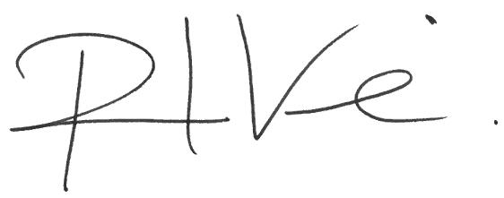

Mr. Paul Vine
Head Teacher

