

Welcome to our first wellbeing newsletter! At Leamington Community Primary School we acknowledge the importance of supporting our children, our families and our staff to live a mentally healthy lifestyle. This year we have decided as a whole school to educate our pupils, parents and staff about mental health, to provide support for those who need it and most importantly to create a culture that talks openly and reduces the stigma surrounding the topic of mental health. Last week, we started our new school year with a focus on teaching our pupils about emotional regulation with the aim to teach pupils to identify emotions in themselves and use personal strategies to regulate these emotions to ensure they are in the optimal ‘zone’ for learning.
Leamington Community Primary School
‘Together we make a Difference’
Friendship, Respect, Honesty, Determination and Courage
Autumn 2020 – Wellbeing- Emotional Regulation

What are the Zones of Regulation?
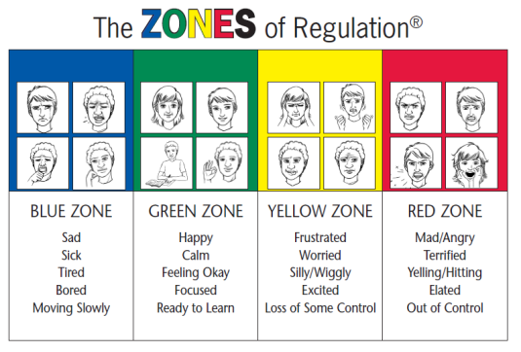
The Zones of Regulation is a curriculum based around the use of four colours to help children self-identify how they’re feeling and categorise it based on colour. The curriculum also helps children better understand their emotions, sensory needs, and thinking patterns. The children learn different strategies to help them cope and manage their emotions based on which colour zone they’re in. Additionally, the Zones of Regulation helps kids recognise their own triggers, learn to read facial expressions, develop problem-solving skills, and become more attuned to how their actions affect other people.
Understanding the zones
The yellow zone describes when you have a heightened sense of alertness. This isn’t
always a bad thing,
and you typically still have some control
when you’re in the
yellow zone.
Being in the yellow means you may feel frustrated, anxious or nervous. But, it could also mean you’re feeling excited, silly, or hyper – which is okay in the right situations.
The blue zone is used when a person is feeling low states of alertness or arousal.
When you’re in the blue zone you may be feeling down – sad, sick, tired, or bored. You’re still in control, as you are in the yellow zone,
but with
low energy
emotions.
The green zone is used to describe when you’re in a calm state of alertness.
Being in the green zone means you are calm, focused, happy, or
ready to learn. This is predominantly
the state you
want your
child to be in.
It’s also the state most needed in the classroom in order to learn.
The red zone describes an extremely heightened state of intense emotions. When a person reaches the red zone, they’re no longer able to control their emotions or reactions.
This is the zone
kids are in during meltdowns.
Being in the red zone means you’re feeling anger, rage, terror, or complete devastation and feel out of control.
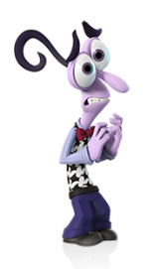

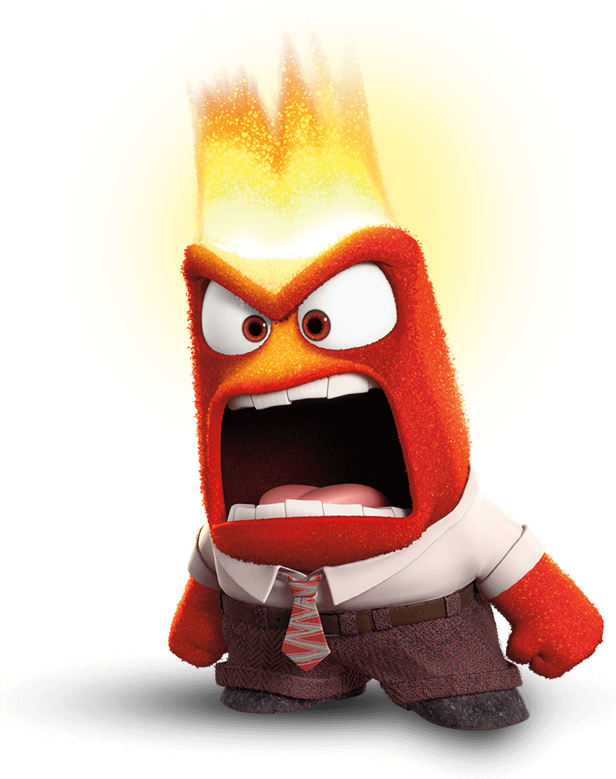




How have we implemented this in Leamington?
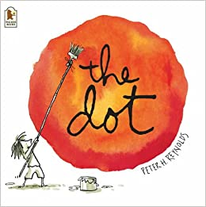
Last week, we started the year off by learning about emotional regulation through the book ‘The Dot’ by Peter H. Reynolds. We learnt about a little girl called Vashti who experienced a variety of emotions throughout her school day and we realised that we all experience a variety of emotions and most importantly, that there are no good or bad emotions (however we may find it easier to learn within the Green Zone). The children will continue to implement this new learning and discuss their emotions through daily check-ins and through continued activities and stories within our daily circle time lessons.
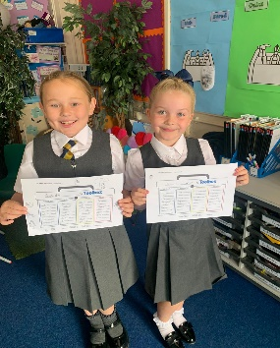
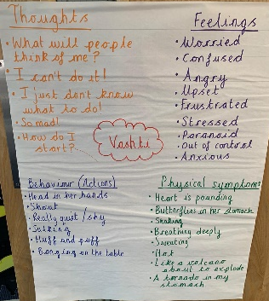
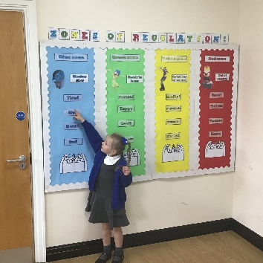
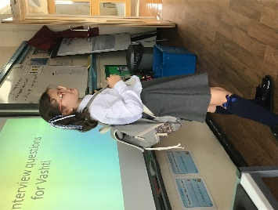
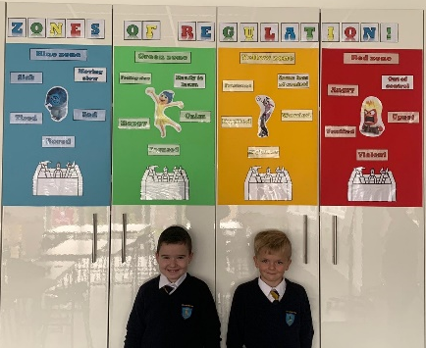

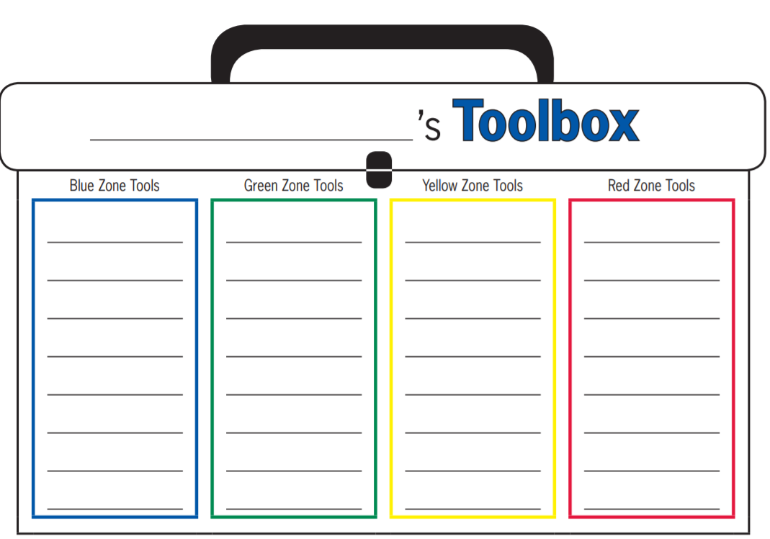
Coping strategies
Once the children acknowledge the zone they are in, it is important that they have coping strategies to help them move into/ or stay in the optimal zone for learning- The ‘Green Zone’. Last week in school, every child designed their own personal tool box of strategies to help them move into the ‘Green Zone’. Here are just some examples from our tool box of support.
Leamington
Breathing techniques
Take time out
Relaxing exercises e.g. yoga/ stretches
Meditation
Keep a journal
Listening to upbeat music
Complete some cardio based exercise
Getting up, showered and dressed
Take time out
Talk to an adult
Use a stress ball
Hug a teddy
Listen to calming music
Use breathing techniques

Self-care- treat yourself to a relaxing bath or night off homework
Organise yourself, make to do lists to prevent stress
Get enough sleep

How to use the Zones at home
Have an open conversation about the Zones of Regulation. Talk through the zones with your child. Ask them how they would feel in each zone and most importantly share your own experiences of being in each zone.
- Discuss what emotion they feel in each zone e.g. in the yellow zone I may feel worried
- How they physically feel e.g. in yellow zone I may have butterflies in my stomach or have sweaty palms (if feeling anxious).
- Then discuss what they might be doing- what are their actions? e.g. in yellow zone would they be pacing around, snapping at others, fidgeting?
- Then discuss how to help them move into the Green zone e.g. if I was in the Yellow zone and feeling anxious I might find completing some yoga stretches/ breathing techniques helps me get back into the green zone.
- Create a list of strategies that work for the child. Remind the child that we are all unique and the strategies that work for one person might not help them and also our strategies may differ depending on whether we are in school, in public places or at home, so they need to think about what would help them in a variety of situations.
- Finally remind your child that we will experience all zones and there are no good or bad zones!
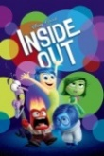
Other ways to support using the Zones of Regulation at home
- Download the Zones of Regulation App. This is an interactive app that teaches children about the zones, how to recognise emotions in themselves and others and suggests support strategies to use.
- Watch the ‘Inside out’ movie with the child and discuss the emotions
Finally:
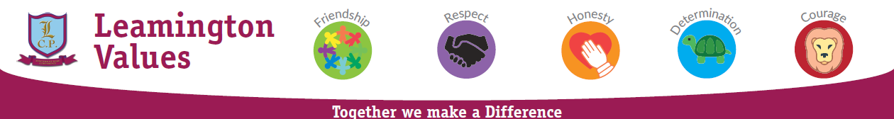
If you have any concerns, worries or need support please don’t hesitate to contact Mrs Maher or Miss Boyd. We are here to support our community and will help in any way we can.

